**EDUNET FOUNDATION - Class Exercise Notebook**

**LAB 1 – Activity- Can you win a Tic Tac Toe game to an Intelligent Piece of Paper?**

Hello Students, let us have an intelligent paper activity.

Here we are going the check the intelligence of an intelligent paper & humanity.

In order to fully comprehend what that means, we must have a concrete example of artificial intelligence. I assert that the piece of paper in question is smarter than everyone else in the room.

I need two volunteers, so what we're going to do is pretend that this piece of paper is exceptionally skilled at knots and crosses. To demonstrate this, we'll need to play some games rather than take some courses, but I don't want to play human against human. Instead, we'll play a game where the piece of paper is competing against humans.

So, read out the moves mentioned in intelligent paper

I am a highly intelligent piece of paper.

Let’s play noughts and crosses.

I am X, and I go first.

**Move 1:** Go in a corner.

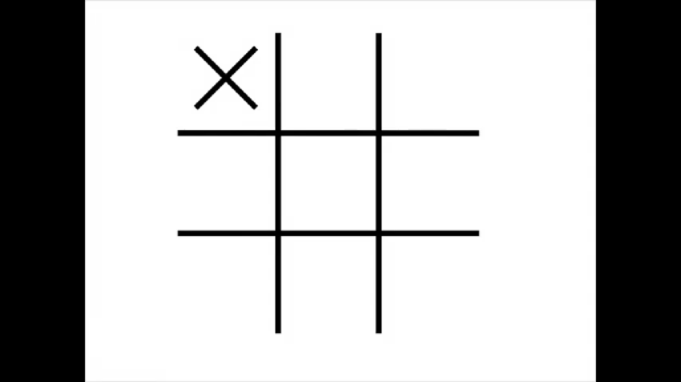

**Humanity Move:**

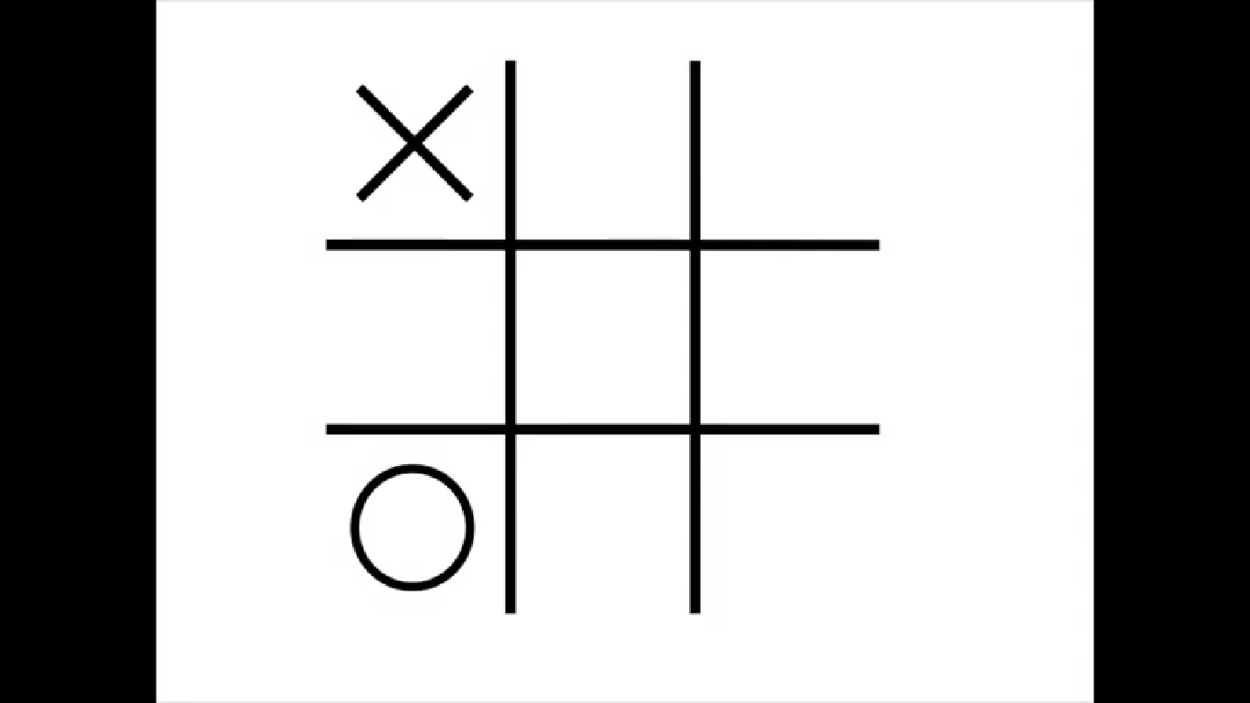

**Move 2**:

IF the other player did not go there

THEN go in the opposite corner to move 1.

ELSE go in a free corner.

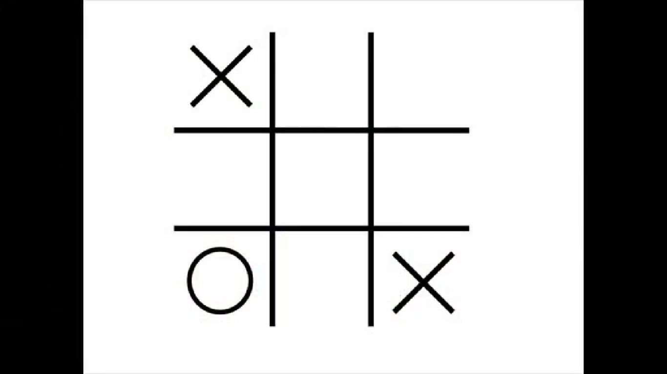

**Humanity Move:**

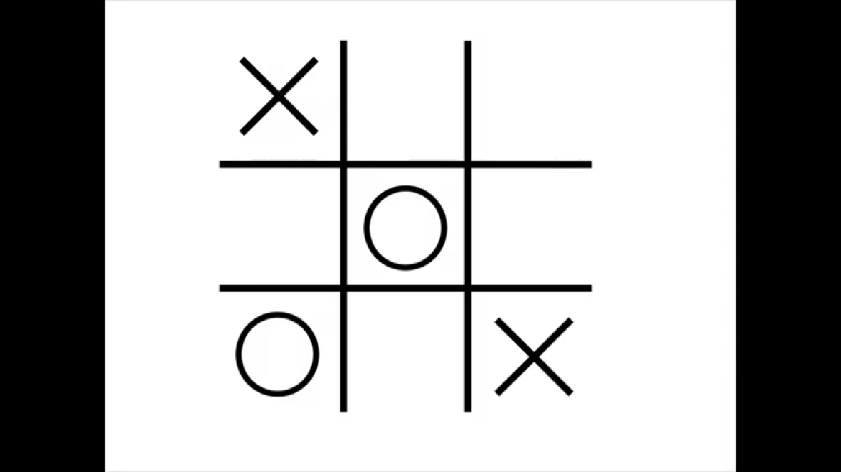

**Move 3:**

IF there are 2 Xs and a space in a line

THEN go in that space.

ELSE IF there are 2 Os and a space in a line

THEN go in that space.

ELSE go in a free corner.

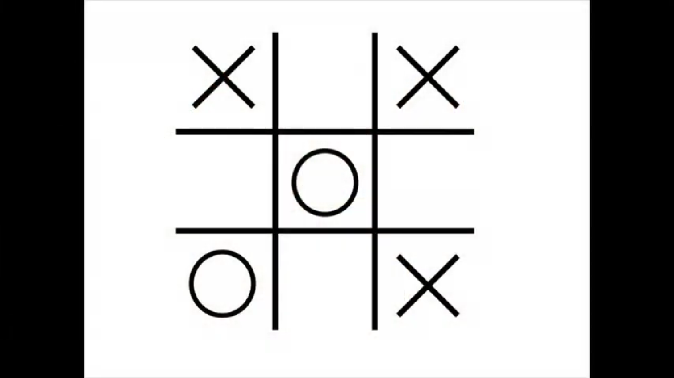

**Humanity Move:**

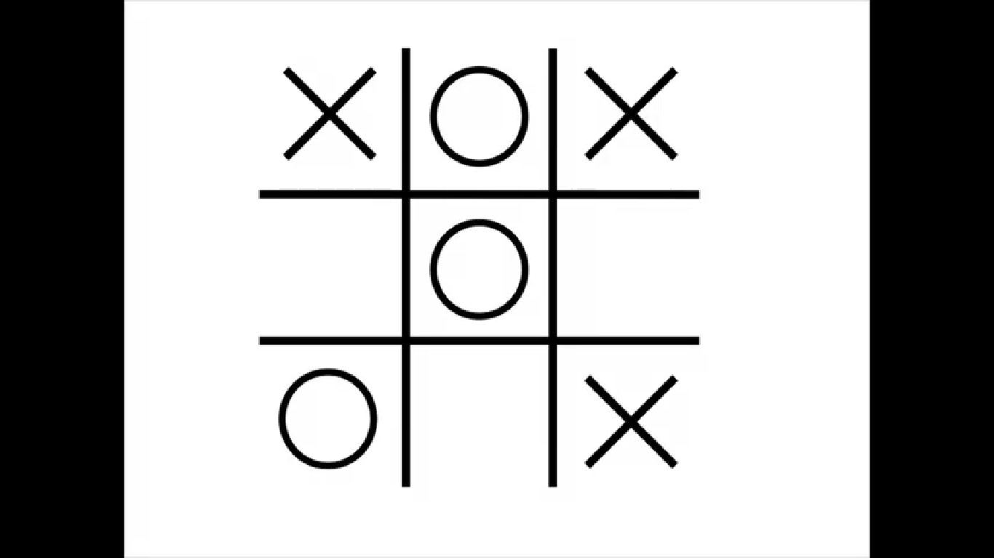

**Move 4:**

IF there are 2 Xs and a space in a line

THEN go in that space.

ELSE IF there are 2 Os and a space in a line

THEN go in that space.

ELSE go in a free corner.

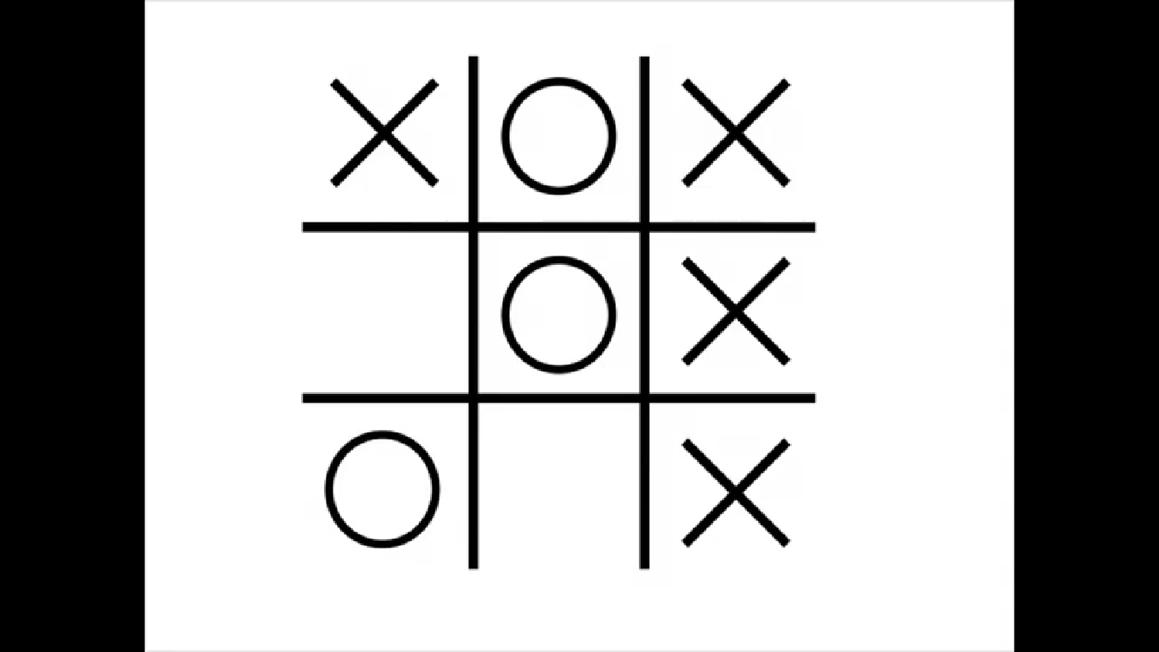

The two volunteers should receive a round of applause for their highly intelligent piece of paper activity, in which the intelligent paper is more intelligent than anyone else in the room.